**S A V O Y S T E W A R T**

**C O M M E R C I A L P R O P E R T Y**

FOR SALE

**Mixed Use / Investment**

**Development For Sale**

* Retail units let at a combined rent of £41,900 pax
* Planning consent granted for redevelopment
* 21 car parking spaces
* Town centre location

**9,152 SqFt (850.22 SqM)**

**For Sale at a guide price of £800,000**

**141 – 145 Queensway, Bletchley MK2 2DY**

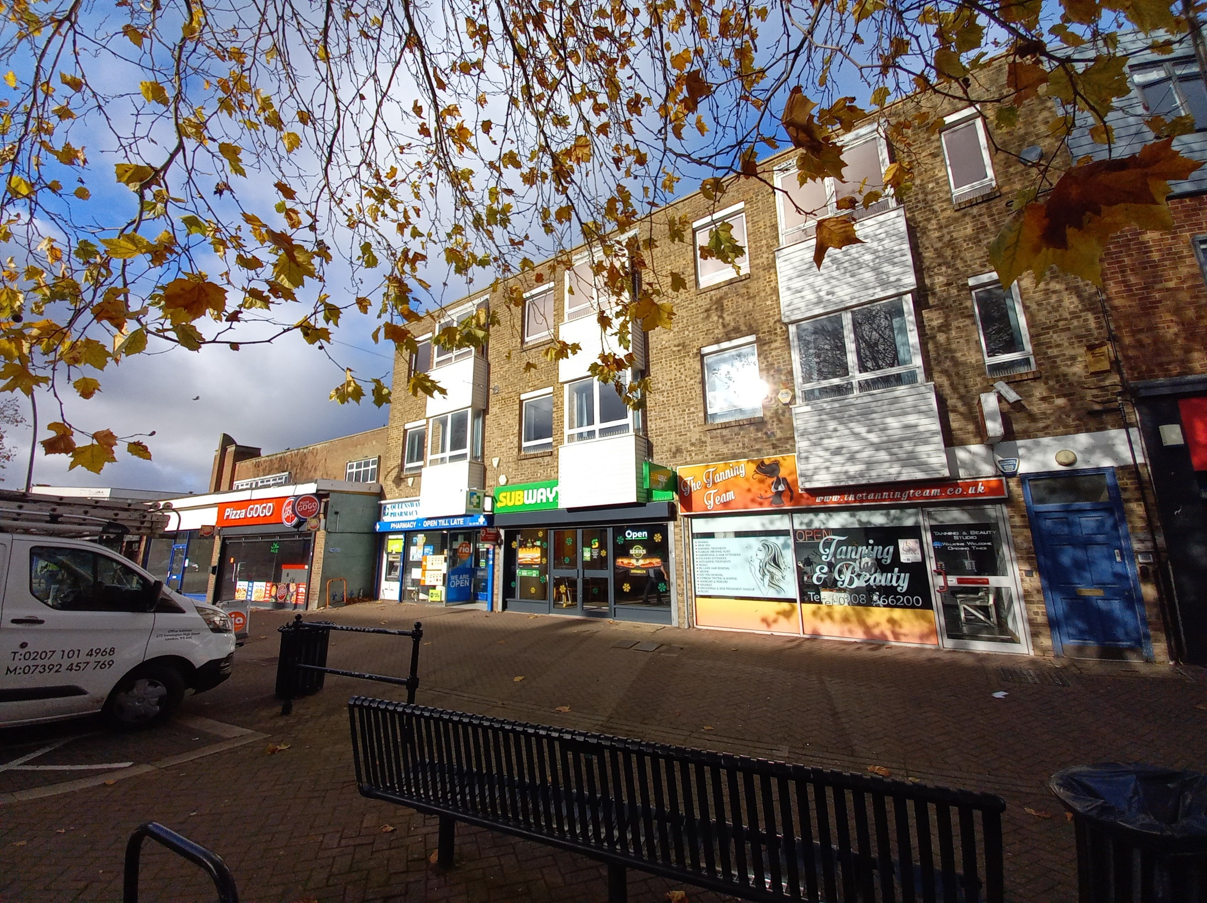

**Accommodation**

A three storey building comprising of a retail investment split into three retail units at ground floor with vacant offices to the first and second floors.

**Planning**

The office element has the benefit of a permitted development approval (Application No: 23/01044/PRIOR) dated 7 August 2023. The consent allows for the conversion of the offices to eight residential units comprising four, two bedroomed apartments and four one bedroomed apartments.

**Floor Area**

The property has been measured in accordance with

the RICS Property Measurements Standard 2nd

Edition.

Accommodation Sq ft Sq M

Total 9,152 850.22

Areas quoted are approximate and should not be held as 100% accurate.

**Viewings**

Strictly by appointment through joint sole agents:

**Stephen Rajbenbach – Savoy Stewart**  
07957 355397

[sr@savoystewart.co.uk](mailto:sr@savoystewart.co.uk)

**Nick Bosworth – Kirby Diamond**

01908 558746

[Nick.bosworth@kirkbydiamond.co.uk](mailto:Nick.bosworth@kirkbydiamond.co.uk)

**There will be open viewing sessions to be conducted on the following dates.**

**Monday 5th February 11am - 11:30am**

**Monday 19th February 11am - 11:30am**

**Monday 4th March 11am - 11:30am**

**Location**  
The premises are located in Queensway, Bletchley close to the entrance of the Brunel Shopping Centre. It is a pedestrianised area forming part of the main retail pitch in Queensway. Nearby occupiers include Coral, Home Bargains, Cash Converters and Barclays.

**Description**  
A self-contained retail investment with vacant first and second floor offices with parking to the rear. Situated within the town centre of Bletchley within a busy shopping parade. There is vehicular access to the rear of the property with parking for 21 cars.

The retail elements are let on the following basis:

143 - A Subhan and S Hussain on a 20 year lease expiring in April 2033 at a rent of £14,400 pax. There is an upwards only rent review and tenants break option in April 2028.

143a - Subway Realty Ltd on a 10 year lease expiring in May 2032 at a rent of £12,500 pax. There is a tenants break option in May 2027 and upward only rent review in May 2027.

143b - The T Team Ltd on a five year lease expiring in November 2028 at a rent of £15,000 pax. The lease is excluded from the security of tenure provisions of the Landlord & Tenant Act 1954 Part II Sections 24-28.

Each tenant has the use of two parking spaces in the rear car park.

**Tenure**The property is available For Sale at a guide price of £800,000 on an informal tender basis with offers to be received by 5.00pm on 18 March 2024.

**VAT**

VAT is not applicable.

**Business Rates**

Interested parties are advised to contact the relevant Local Authority.

**EPC**

TBC